Release Notes Appendix
24/10/2025

Enhanced ordering flow
In the installed version of the software, the same features available in the existing web version have been introduced. A new step in the ordering mechanism allows partial ordering (removing some parts from the order, but not from the project) and attaching additional files to the order. After the user selects the Production Center and presses the Next button, a new page is displayed. This new page allows users to remove parts from the order (1), change the material (2) or color (3), or attach additional files (4). The original project stored on the customer's hard drive will not be modified by these changes. All modifications are performed in memory and apply only to the current order!
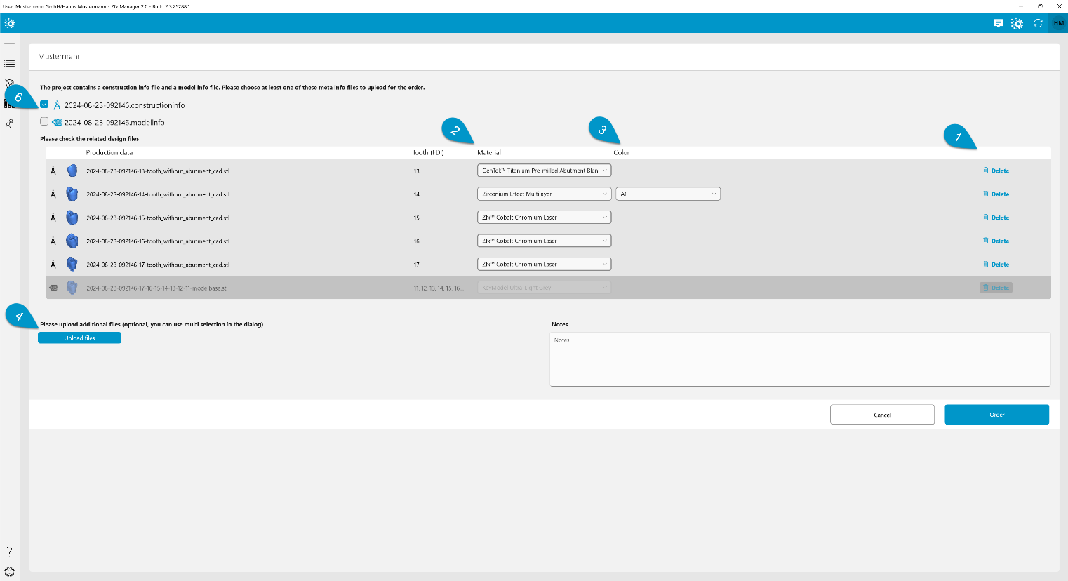
For 3Shape cases, CAM-relevant files will be automatically loaded and added to the order (5). These files cannot be removed from the order.

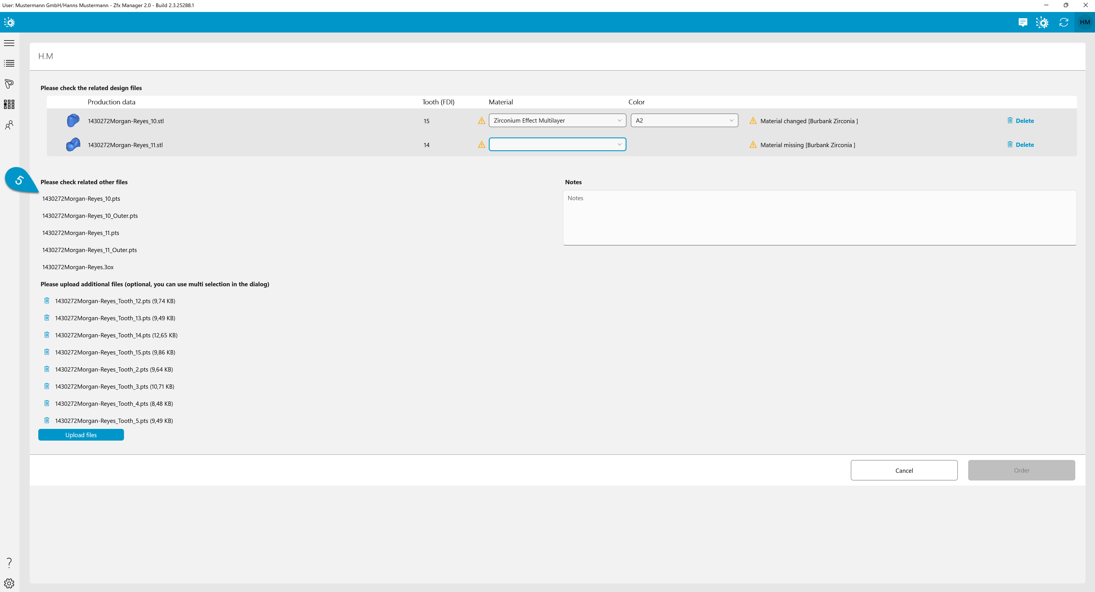
There is also an enhancement for order cases where both construction info and model info are present. The user can easily control whether production should be based on construction info, model info, or both (6). For model info, it is also possible to remove parts from the order or change the material or color.
After the user presses Order, they will receive an offer page reflecting the applied changes and can proceed to place the order as usual.

Order Details: Quality Control Enhancements
In the Order Details – Products tab, the quality control section has been updated. The goal was to simplify and reduce the number of quality categories so that they can be generalized across all services and indications. The new system includes two quality checks: Production Check (1) and End-of-Line Check (2).
To proceed with shipping or pickup, all products within the given order must pass the End-of- Line Check. The Production Check can be skipped, as the necessity to perform this may vary depending on the internal processes of the respective Production Center.
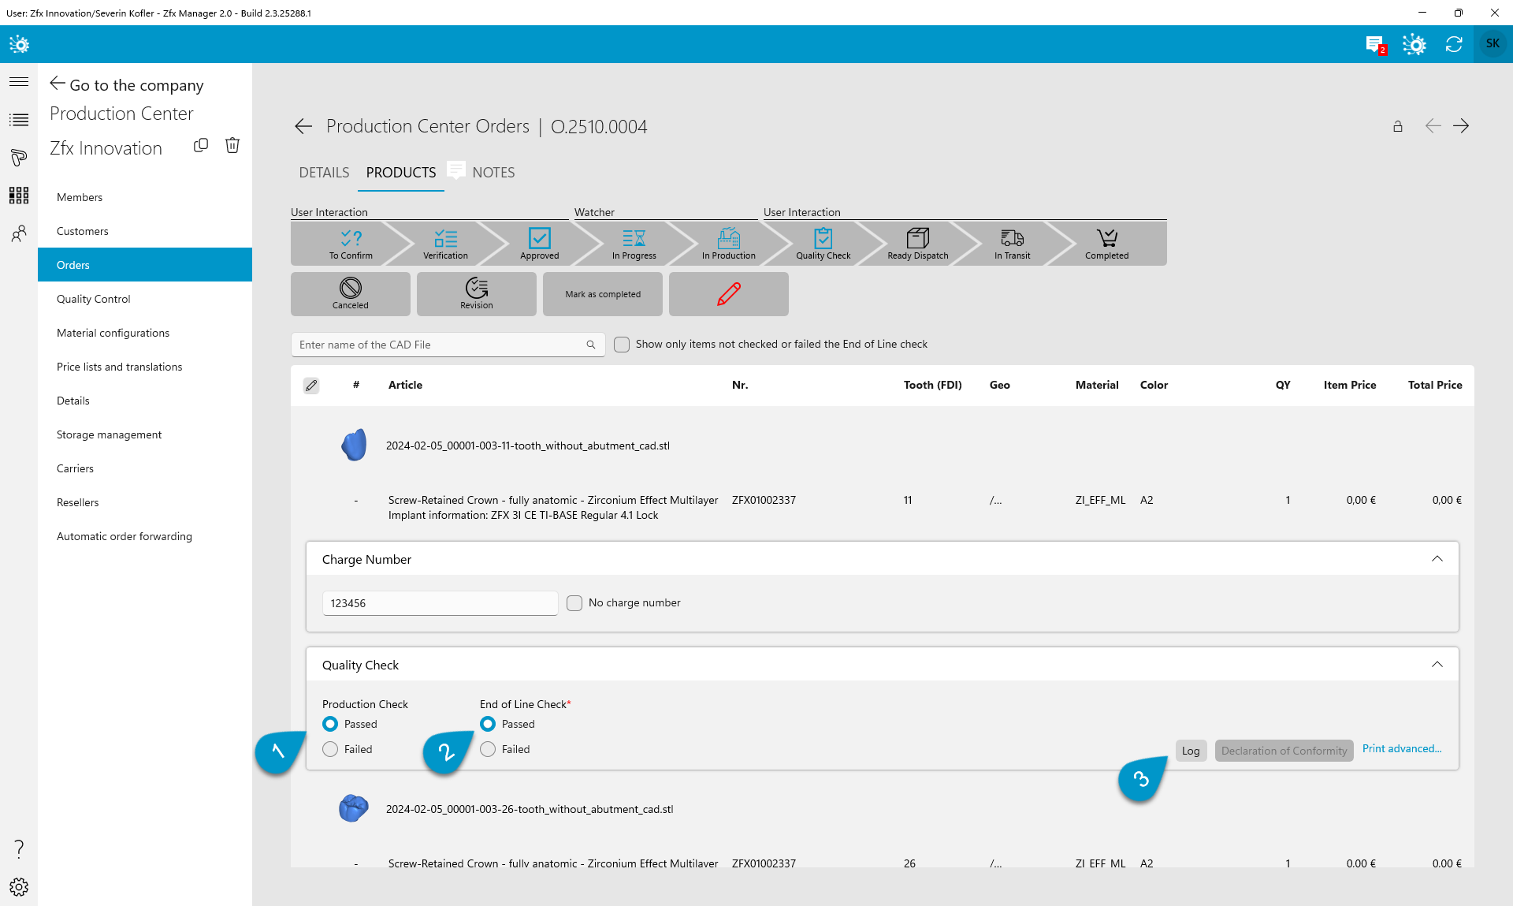

All performed quality control actions are logged, and an overview can be accessed via the Log
(3) button.

Standalone Quality Control Enhancements
The standalone Quality Control module, accessible from the Production Center menu (1), has been updated to reflect changes in the quality control categories. It now includes only two categories: Production Check and End-of-Line Check.
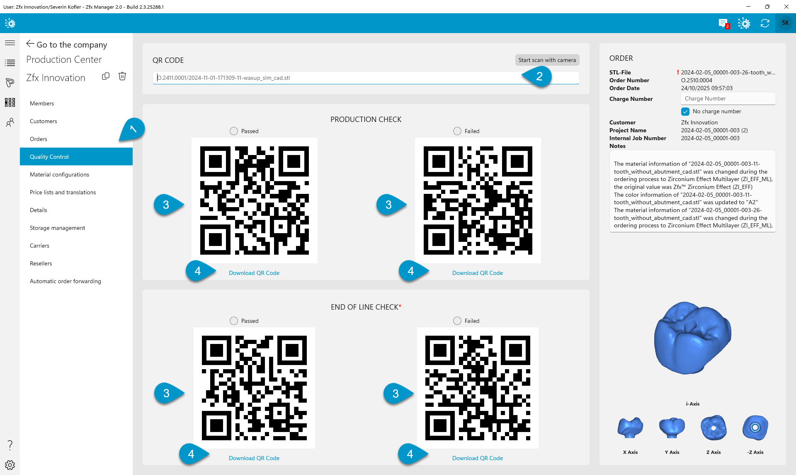
The user interface has been redesigned that it can be operated also via a QR code reader, enhancing productivity. First, the QR code of the product is scanned (2), then the QR code indicating whether the check was passed or failed is scanned (3). Similar to the order details, only the End-of-Line Check is mandatory. The QR codes can be printed and used in a printed form (4).

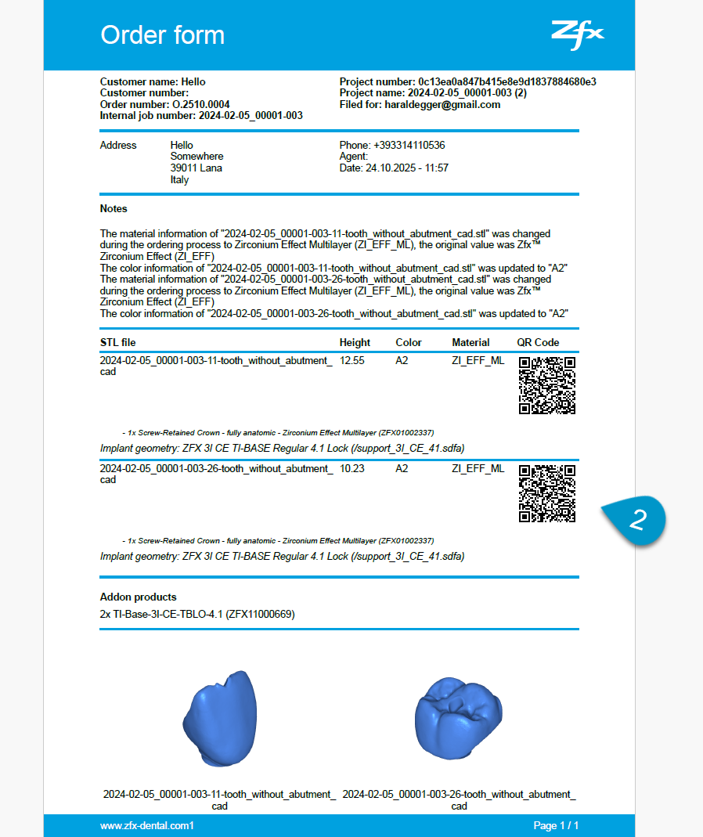
Once all parts related to an order pass the End-of-Line Check, the order transitions to the Ready to Dispatch status, and all controls related to the order are disabled (5). If this was by mistake, to assist users in this situation, we’ve introduced a Recheck this part (6) button. This button appears only if the order was moved to the Ready to Dispatch status by passing the End-of-Line Check for the last part. When pressed, the order is returned to Quality Check status and the of End-of-Line Check of the displayed part is reset to not defined.
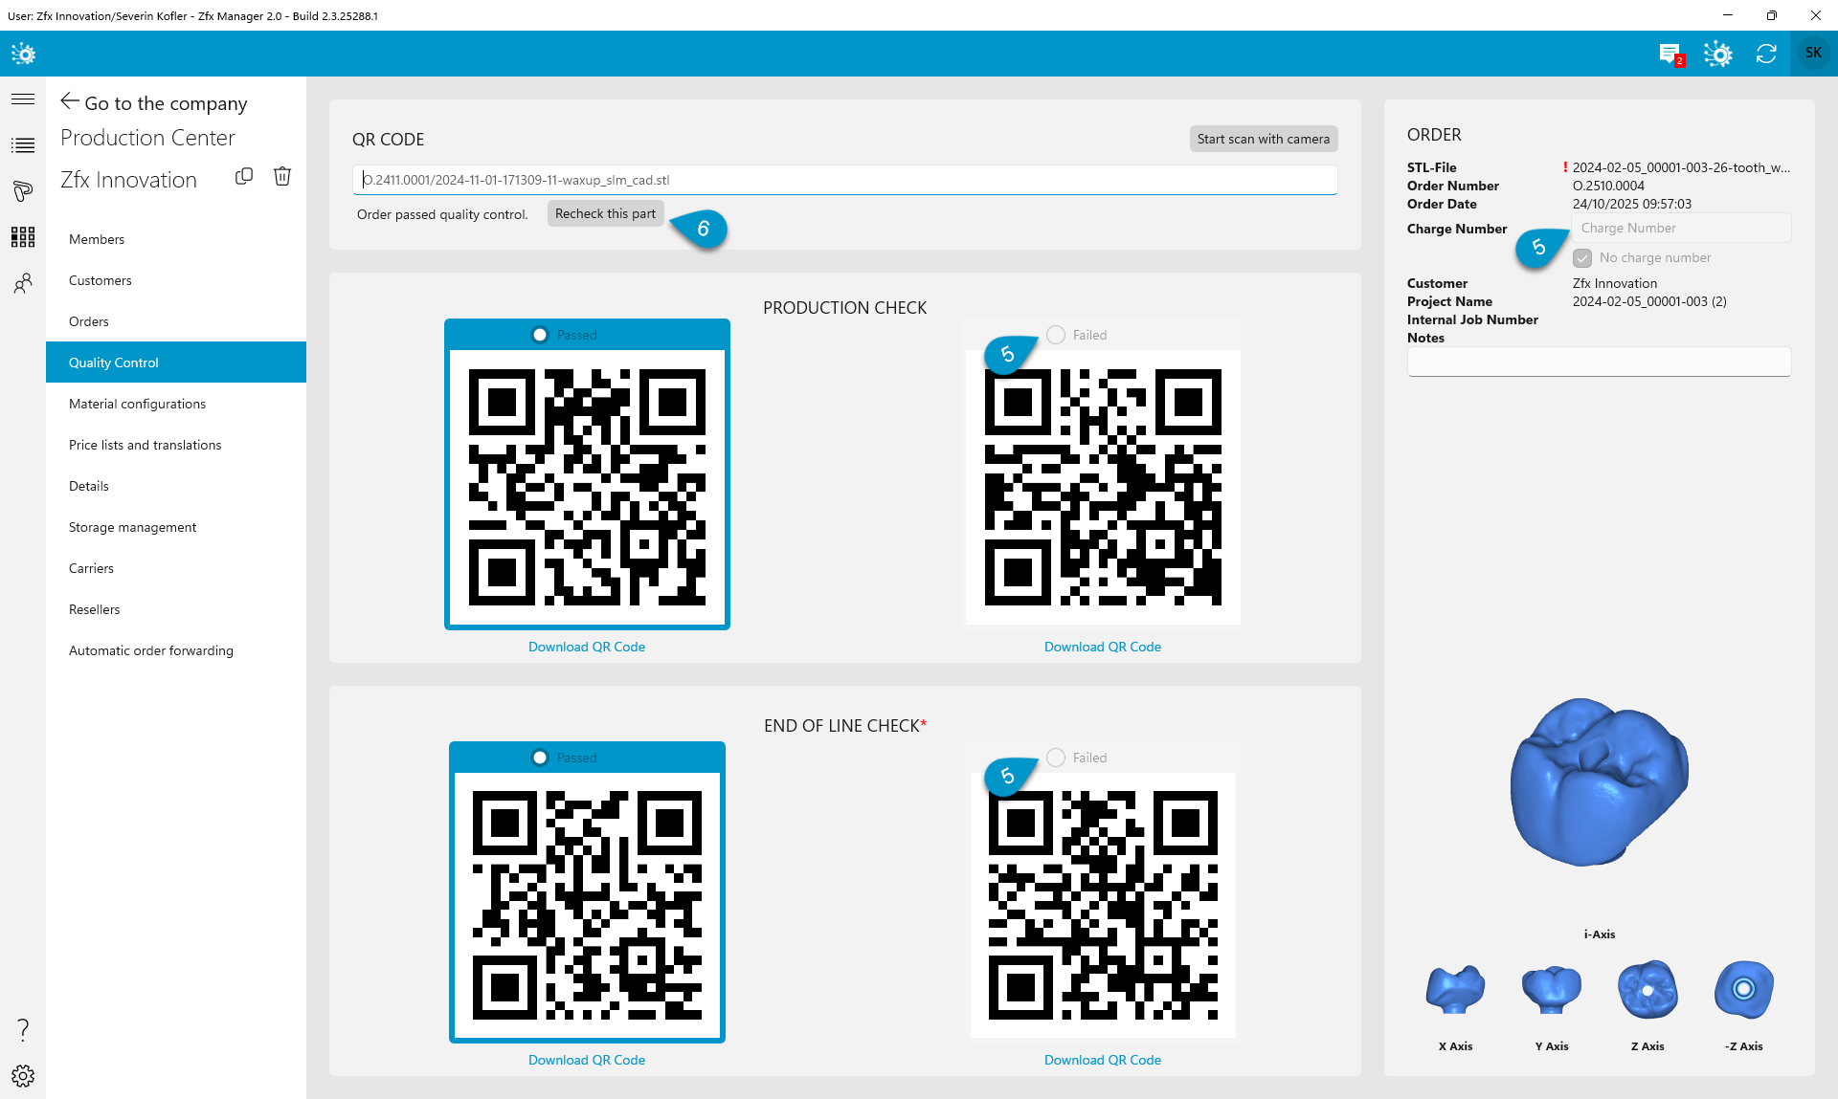
If any part fails the End-of-Line Check, the order will not move to the Ready to Dispatch status and will remain in the Quality Check status.

